**Aim:**

**Implementation of application using suitable data structures and files.**

**Project Description:**

**This project is about how a library system should be managed in a college or school in by this code we can save this list of book taken by a school/college student and when it was taken and how many which type of book was taken it will save this record in the text file.**

**Data Structure used:**

**Linked list is used while making this project.**

**Code:**

#include <stdio.h>

#include<conio.h>

#include<stdlib.h>

#include<time.h>

#include<string.h>

struct books

{

    int id;

    char bookn[50];

    char authorn[50];

    char date[12];

}b;

struct student

{

    int id;

    char sname[50];

    char sclass[50];

    int sroll;

    char bookn[50];

    char date[12];

}s;

FILE *fp;

void addbook()

{

    char mydate[12];

    time_t t = time(NULL);

    struct tm tm =*localtime(&t);

    sprintf(mydate,"%02d/%02d/%d",tm.tm_mday,tm.tm_mon+1,tm.tm_year + 1900);

    strcpy(b.date,mydate);

    fp = fopen("book.text","ab");

    printf("Enter Book ID: ");

    scanf("%d",&b.id);

    printf("Enter Book name: ");

    fflush(stdin);

    gets(b.bookn);

    printf("Enter Author Name: ");

    fflush(stdin);

    gets(b.authorn);

    printf("Book added Sucessfully !!!!");

    fwrite(&b , sizeof(b),1,fp);

    fclose(fp);

}

void booklist()

{

    system("cls");

    printf("*Available Books*\n\n");

    printf("%-10s %-30s %-20s %s\n\n","Book id", "Book Name", "Author", "Date");

    fp = fopen("book.text","rb");

    while(fread(&b , sizeof(b) , 1, fp)==1)

    {

         printf("%-10d %-30s %-20s %s\n\n",b.id,b.bookn,b.authorn,b.date);

    }

    fclose(fp);

}

void del()

{

    int id,f=0;

    system("cls");

    printf("*Remove Books*\n\n");

    printf("Enter Book Id to remove");

    scanf("%d",&id);

    FILE *ft;

    fp = fopen("book.txt","rb");

    ft = fopen("temp.txt","wb");

    while(fread(&b , sizeof(b) , 1, fp)==1)

    {

        if(id==b.id)

        f=1;

        else

        fwrite(&b,sizeof(b),1,ft);

    }

    if(f==1)

    {

        printf("\n\nDeleted Sucessfully!!!");

    }

    else

    {

        printf("\n\nRecord not found!!!");

    }

    fclose(fp);

    fclose(ft);

    remove("book.txt");

    rename("temp..txt","book.txt");

}

 void issueb()

 {

    char mydate[12];

    time_t t = time(NULL);

    struct tm tm =*localtime(&t);

    sprintf(mydate,"%02d/%02d/%d",tm.tm_mday,tm.tm_mon+1,tm.tm_year + 1900);

    strcpy(s.date,mydate);

    int f;

    system("cls");

    printf("**Issue Books**");

    printf("\nEnter Book Id to issue: ");

    scanf("%d",&s.id);

    fp = fopen("book.txt","rb");

     while(fread(&b, sizeof(b), 1, fp) == 1){

        if(b.id == s.id){

            strcpy(s.bookn, b.bookn);

            f=1;

            break;

        }

    }

    if(f==0){

        printf("No book found with this id\n");

        printf("Please try again...\n\n");

        return;

    }

    fp = fopen("issue.txt", "ab");

    printf("Enter Student Name: ");

    fflush(stdin);

    gets(s.sname);

    printf("Enter Student Class: ");

    fflush(stdin);

    gets(s.sclass);

    printf("Enter Book name:  ");

    fflush(stdin);

    gets(s.bookn);

    printf("Enter Student Roll: ");

    scanf("%d", &s.sroll);

    printf("Book Issued Successfully\n\n");

    fwrite(&s, sizeof(s), 1, fp);

    fclose(fp);

}

void issuel(){

    system("cls");

    printf("** Book Issue List **\n\n");

    printf("%-10s %-30s %-20s %-10s %-30s %s\n\n", "S.id", "Name", "Class", "Roll", "Book Name", "Date");

    fp = fopen("issue.txt", "rb");

    while(fread(&s, sizeof(s), 1, fp) == 1){

        printf("%-10d %-30s %-20s %-10d %-30s %s\n", s.id, s.sname, s.sclass, s.sroll, s.bookn, s.date);

    }

    fclose(fp);

}

int main()

{

    int ch;

    while(1)

    {

        system("cls");

        printf("**LIBRARY MANAGEMENT SYSTEM**\n\n");

        printf("ADD BOOK---> 1\n");

        printf("BOOK LIST--->2\n");

        printf("REMOVE BOOK--->3\n");

        printf("ISSUE BOOK--->4\n");

        printf("ISSUED BOOK LIST--->5\n");

        printf("Exit--->0\n\n\n");

        printf("Enter your choice : ");

        scanf("%d",&ch);

        switch (ch)

        {

        case 1 :

            addbook();

            break;

        case 2:

            booklist();

            break;

        case 3:

            del();

            break;

        case 4:

            issueb();

            break;

        case 5:

            issuel();

            break;

        case 6:

            exit(0);

        default:

            printf("\nINVALID CHOICE!!");

            break;

        }

        printf("\nPress Any key to continue");

        getch();

    }

}

**Steps to run the application:**

**As we run this program it will**

**ADD BOOK---> 1**

**BOOK LIST--->2**

**REMOVE BOOK--->3**

**ISSUE BOOK--->4**

**ISSUED BOOK LIST--->5**

**Exit--->0**

**If you press 1 it will ask to enter book id then book name then author name and book will be added successfully**

**Enter Book ID: 567**

**Enter Book name: to be with you**

**Enter Author Name: yash**

**Book added Sucessfully !!!!**

**Press Any key to continue**

**Press any key to continue.**

**If you press Issue book it gone ask you book id, student name, class, book name and roll no.**

**\*\*Issue Books\*\***

**Enter Book Id to issue: 576**

**Enter Student Name: yash**

**Enter Student Class: 4**

**Enter Book name: need for you**

**Enter Student Roll: 343**

**Book Issued Successfully**

**If you select 5 it will ask id and it will remove from the stock.**

**Screen Shots of UI:**

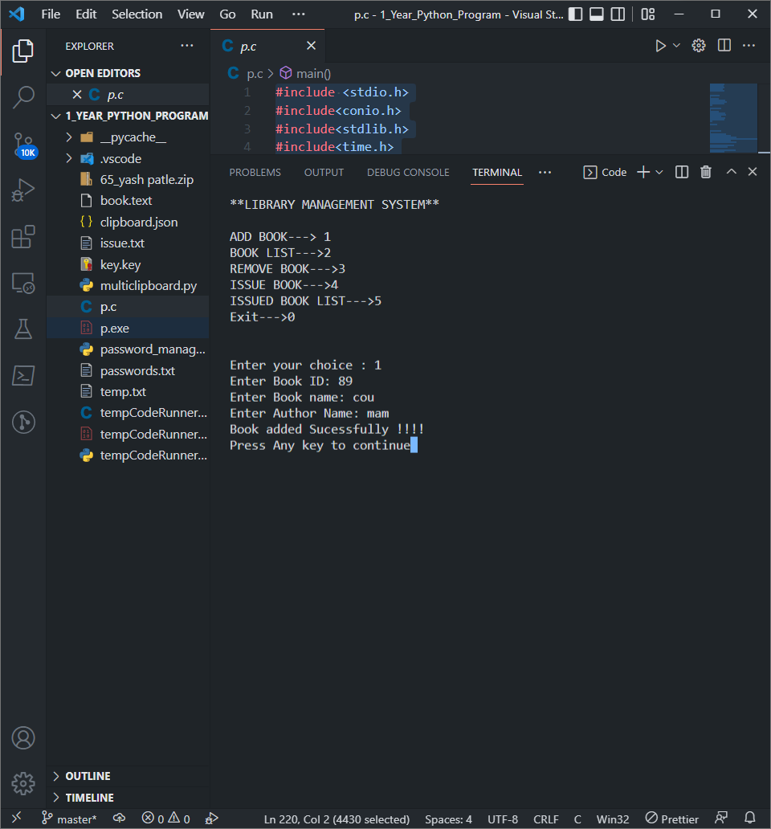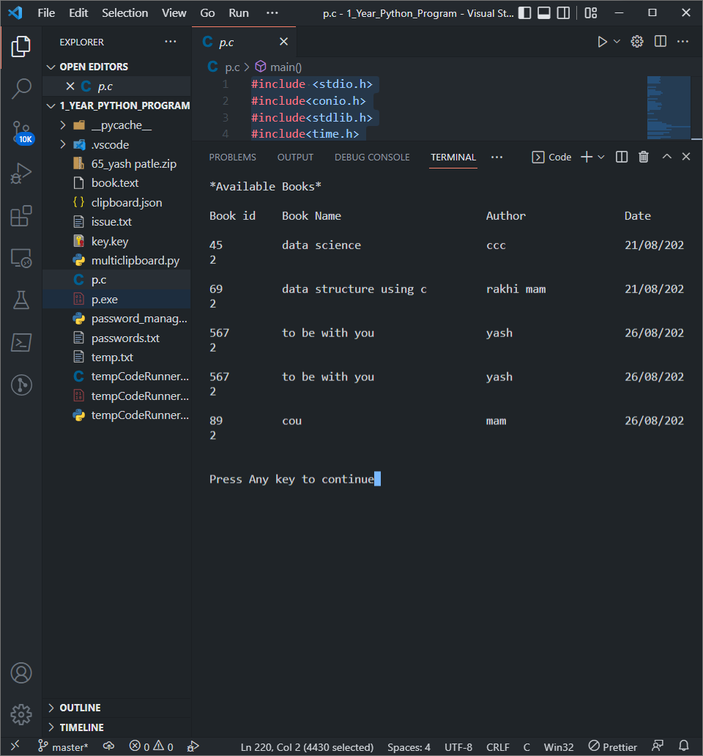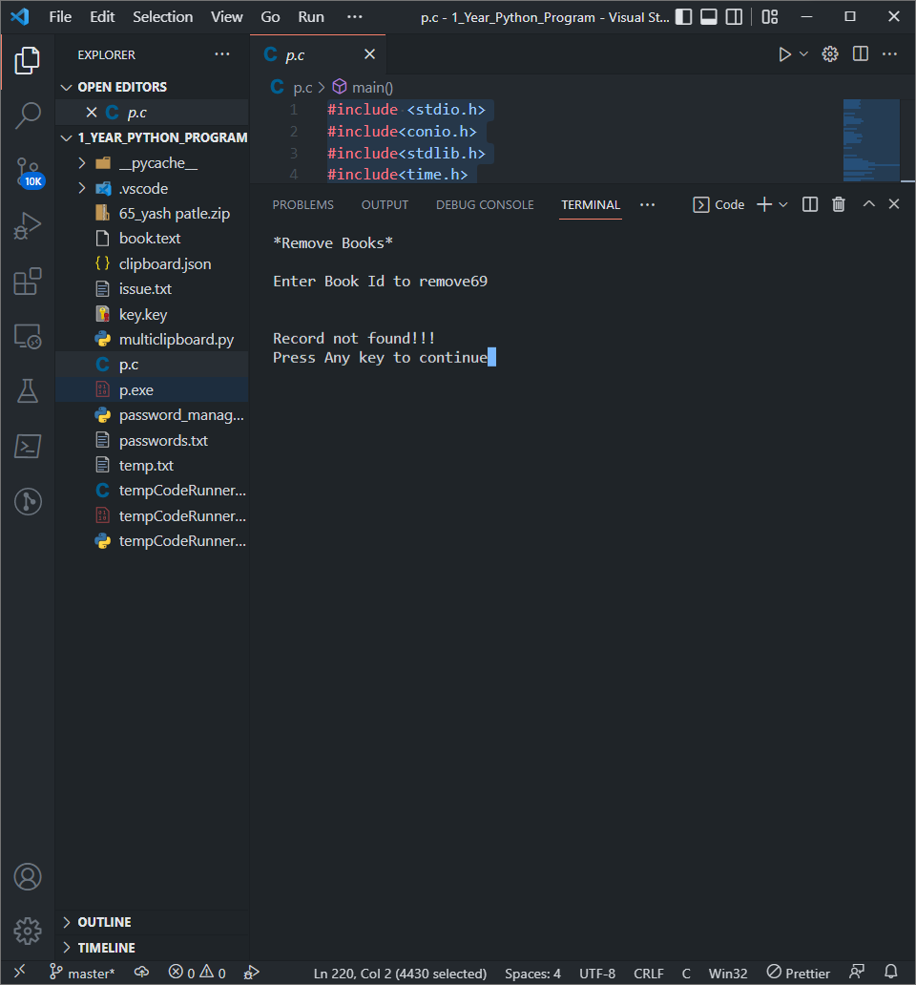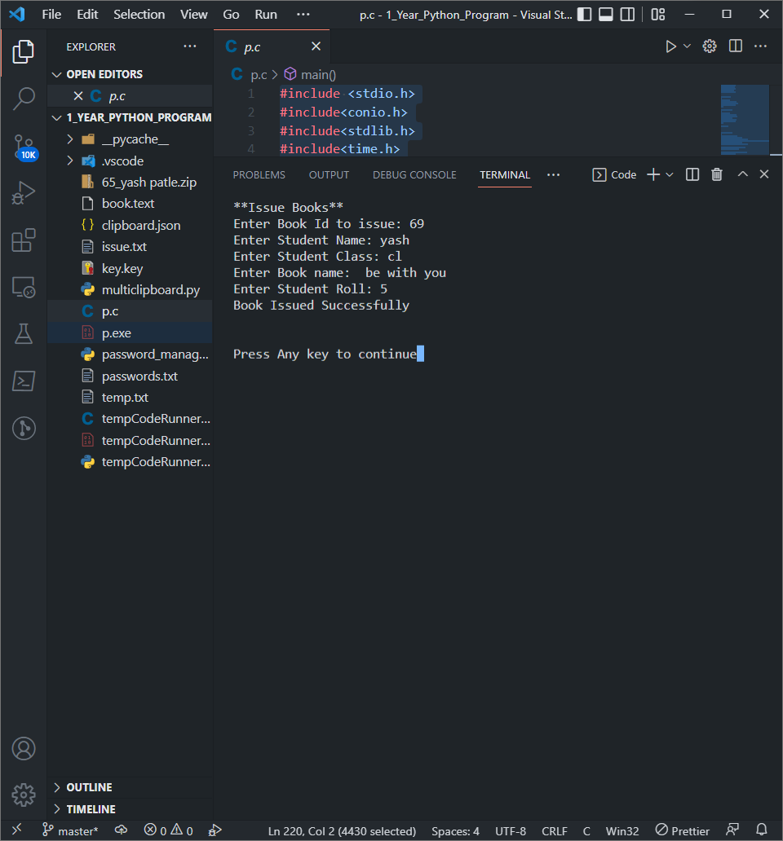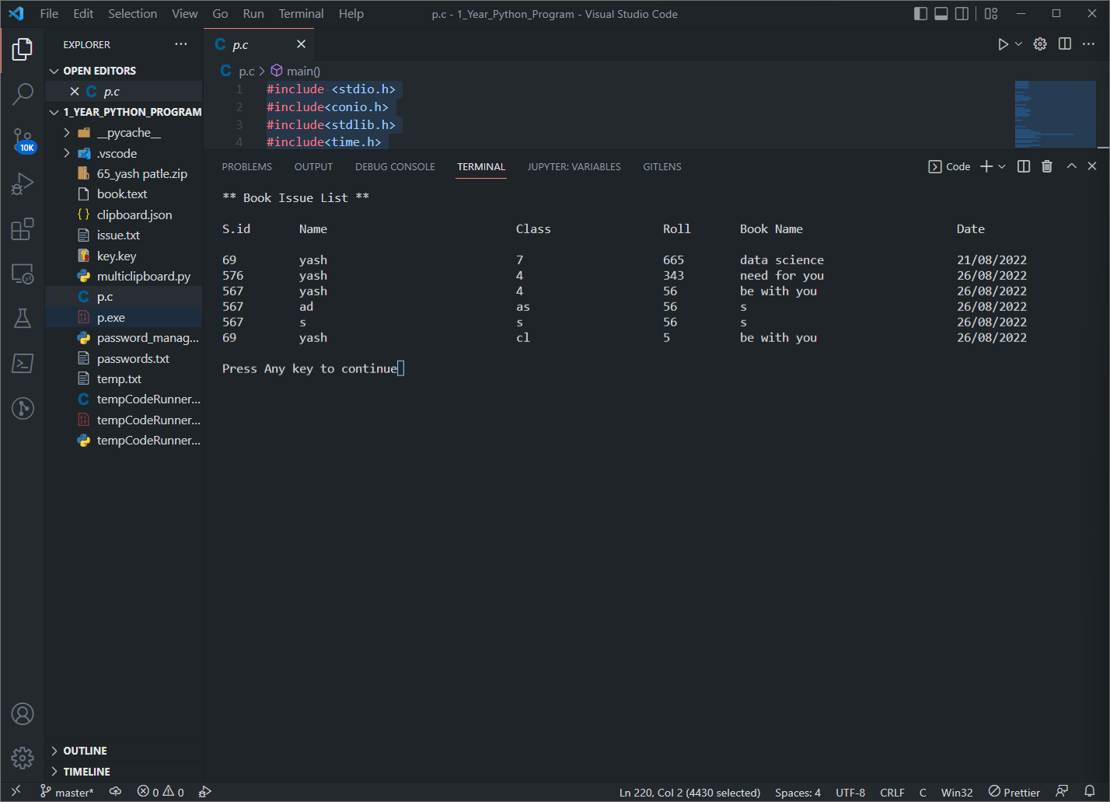

**Conclusion:**

**The program is successfully executed.**